MODIFICATION TO Y MOTOR POWER & ENCODER LEADS

- PARTS:

QUANTITY: PART #: NOMENCLATURE: LENGTH:

1 PER MACHINE 212032- REWORK, Y-AXIS MOTOR N/A

1 PER MACHINE 17024- CONNECTOR, 2-PIN MALE N/A

2 PER MACHINE 17022- PIN, CONNECTOR N/A

1 PER MACHINE 17585-3 HOUSING, 4-PIN N/A

4 PER MACHINE 18729- TERMINAL, CRIMP, GOLDPLATED N/A

1 PER MACHINE 46776- SLEEVE, ¼” BLACK 3.5 INCHES

- POWER CABLE ASSEMBLY:

- CUT THE RED AND BLACK WIRES, TO MOTOR POWER, TO 4 INCH LENGTHS.

- SLIDE THE SLEEVING OVER THE WIRES.

- STRIP 1/8” OF INSULATION FROM THE ENDS OF THE WIRES.

- CRIMP AND TIN THE PINS TO THE WIRES ACCORDING TO DIAGRAM 1.

- INSERT THE PINS INTO THE CONNECTOR ACCORDING TO DIAGRAM 2.

NOTE 1
IT IS CRITICAL TO INSERT THE PINS IN THE CORRECT COLOR ORDER. ANY VARIATION MAY CAUSE DAMAGE TO THE MOTOR OR TO THE MACHINE.



DIAGRAM 1

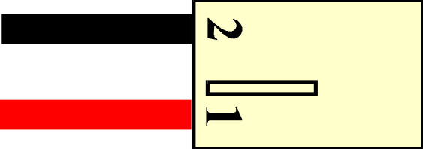

DIAGRAM 2

- ENCODER CABLE ASSEMBLY:

A. CUT THE FOUR WIRES, TO MOTOR ENCODER, TO 14 INCH LENGTHS.

- STRIP 1/8” OF INSULATION FROM THE ENDS OF THE WIRES.

- CRIMP AND TIN THE PINS TO THE WIRES ACCORDING TO DIAGRAM 3.

- INSERT THE PINS INTO THE CONNECTOR ACCORDING TO DIAGRAM 4.

NOTE 1
IT IS CRITICAL TO INSERT THE PINS IN THE CORRECT COLOR ORDER. ANY VARIATION MAY CAUSE DAMAGE TO THE MOTOR OR TO THE MACHINE.
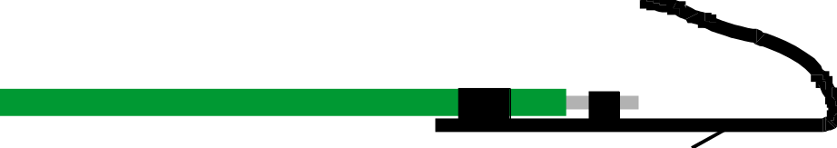

DIAGRAM 3

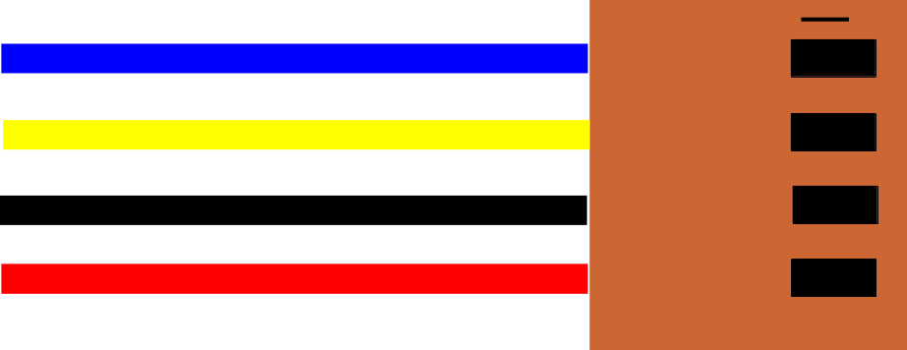

DIAGRAM 4

